**Lab Report 4 - Actuator**

**Nancy Hoang (ndh9tsj)**

**Exercise #1**

1. Change AIN1 pin output to HIGH and AI2 output to LOW. **What happens? Why do you think it happened?**
   1. The motor started to spin in the opposite clockwise direction instead. I think that this happened because in the Control Function Truth Table if AIN1 is HIGH and AIN2 is LOW then the direction is CW whereas in the original where the AIN1 is LOW and AIN2 is HIGH, the direction is CCW.
2. Change analog output parameter for PWM pin to 200. **What happens? Why do you think it happened?**
   1. The speed of the motor spins much quicker and this happens because increasing the PWM signal will increase the rotation speed.
3. **Which parameter do you need to change to make the motor run slower?**
   1. To make the motor run slower, we can decrease the PWM parameter.

**Exercise #2**

1. **Change the delay to 100ms. What happens?**
   1. The servo motor starts to rotate much quicker than when the delay was 1000ms.
2. **What should you change to make the servo to make a 1 degree rotation each second, instead of 10 degrees?**
   1. We need to change the line to be “myservo.write(i*1);

**Assignment**

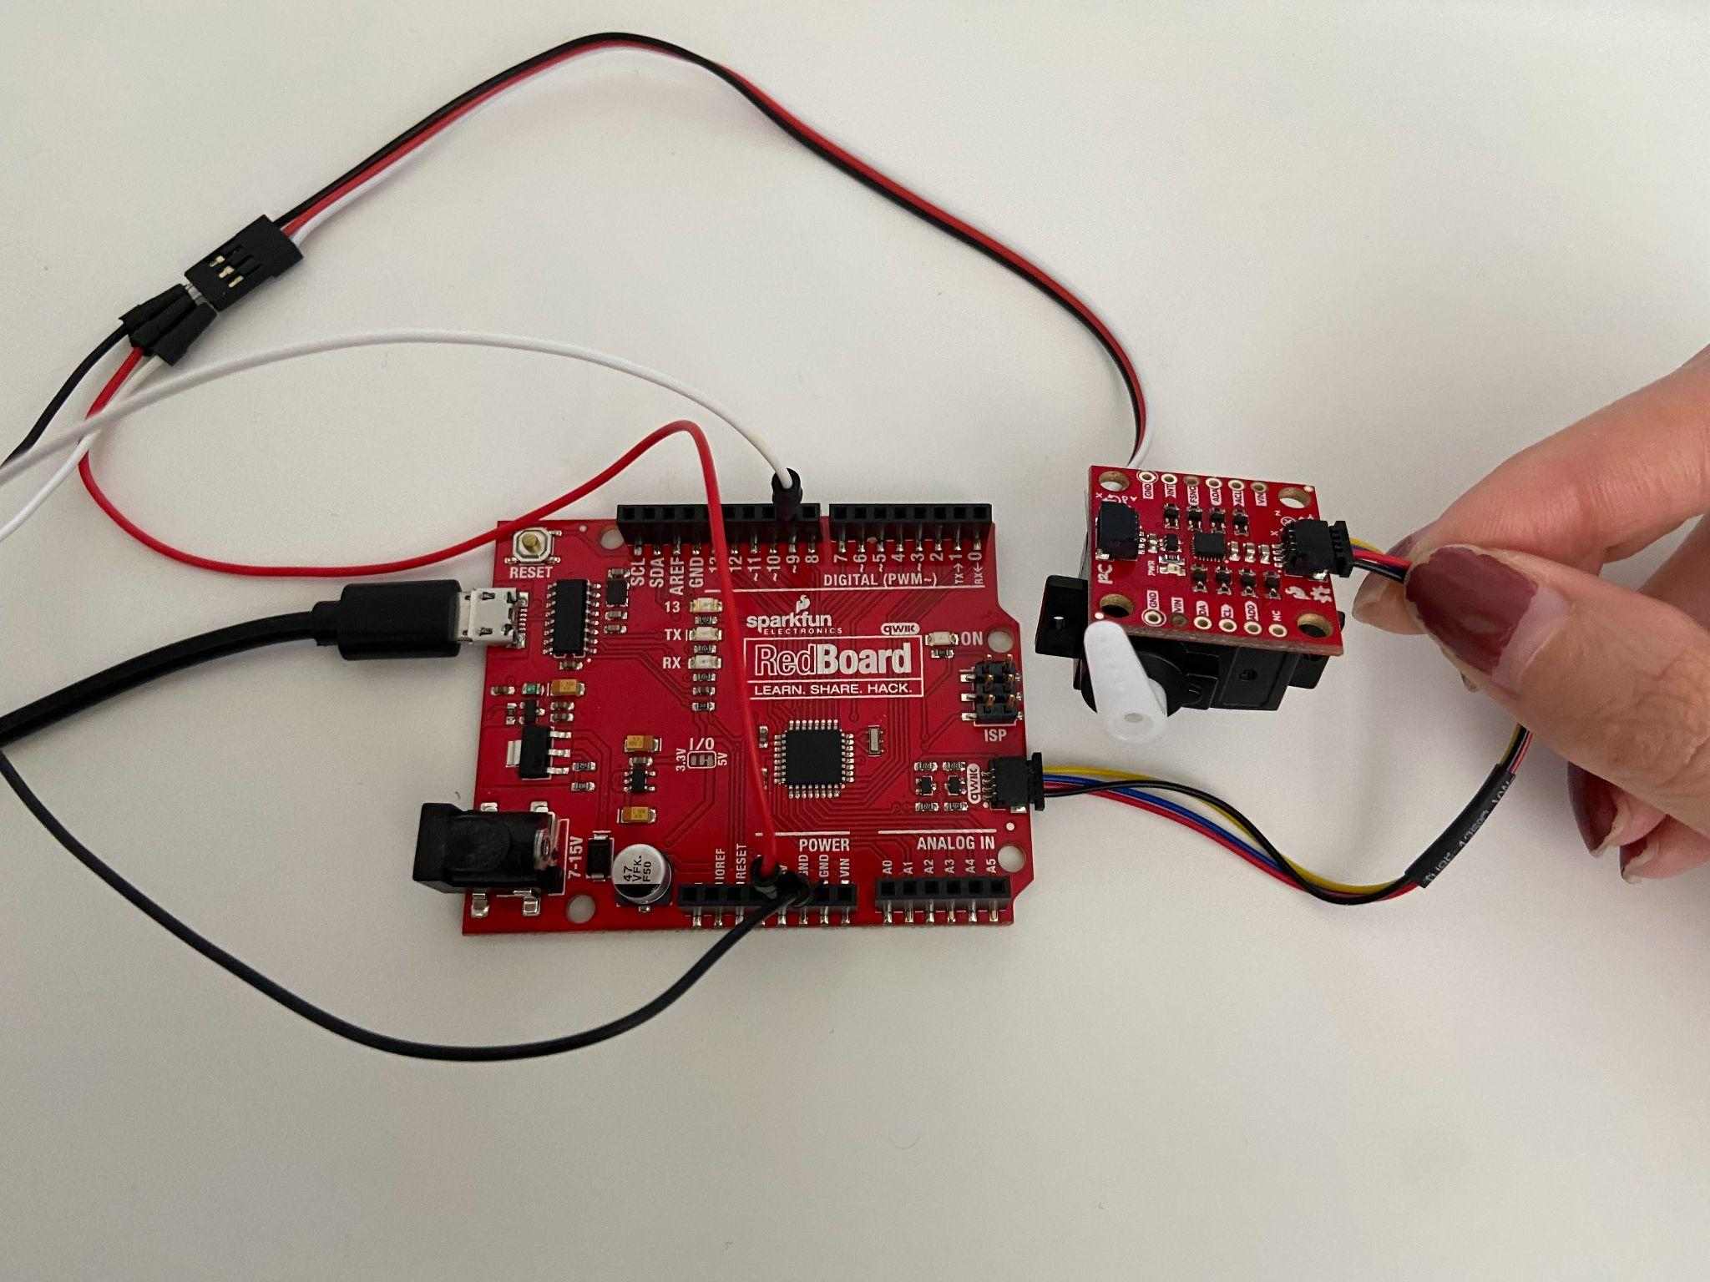

**Code:**

#include <Servo.h>

#include "ICM_20948.h"

ICM_20948_I2C myICM;

Servo myservo;

int angle = 0;

void setup() {

Serial.begin(115200);

Wire.begin();

Wire.setClock(400000);

myICM.begin(Wire, 1);

myservo.attach(9);

}

void loop() {

// Getting IMU data

if ( myICM.dataReady() ) {

myICM.getAGMT();

float ax = myICM.accX();

Serial.println(ax);

ax = map (ax, -1100, 1100, 180, 0) ;

myservo.write(ax);

delay(1000);

}

}